IT 327 - Lab #11

Digital Channel Testing: QAM Constellations, Eye Patterns

# Objective

To gain understanding of QAM and PSK constellation diagrams using M-Level encoding as well as decoding. Generate an eye pattern using an oscilloscope.

# Procedures for QAM and PSK Constellation Plots

# Step1

For this part of the lab you will need the Signal Constellations section of the TIMS manual. This can be found on IT 327 lab website under Lab 9 “Aids” as a pdf file or pages 79-88 in Volume D-1 in the lab. Briefly read the first few pages before moving onto the lab experiment section.

# Step 2

Complete steps T1, T2, and T3. Make sure to predict the appearance of the constellation diagrams. In step T3, connect the “Q” and “I” outputs to “A” on the scope selector. Make sure you switch the oscilloscope display format from “YT” to “XY.

## Step T1

Obtain an M-LEVEL ENCODER module. Before plugging it in, make sure that the on-board jumper J3 is in the ‘NORMAL’ position. To do this take the module out and physically make sure the switch is on normal.

## Step T2

Connect cables as designed in the Figure below. Start with a short sequence from the SEQUENCE GENERATOR, make sure both toggles of the on-board switch SW2 are UP, and select 4-QAM from the M-LEVEL ENCODER.

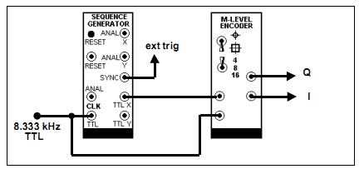

## Step T3

Predict the look of the constellation diagram, display it on the oscilloscope (I and Q signals connect to the X and Y inputs of the oscilloscope to represent the complex plane with imaginary axis vertical). Deduce the coding scheme of the 4-QAM signal. By examining simultaneously the input data and each one of the “I” and “Q” output signals in turn. The encoder will have arbitrarily selected the frame start point in the incoming serial binary data stream. Each frame will contain two data bits (for the 4-QAM case). Try this on a piece of paper and do the best you can to try to understand and figure out the plots.

### 4 point Square Prediction:

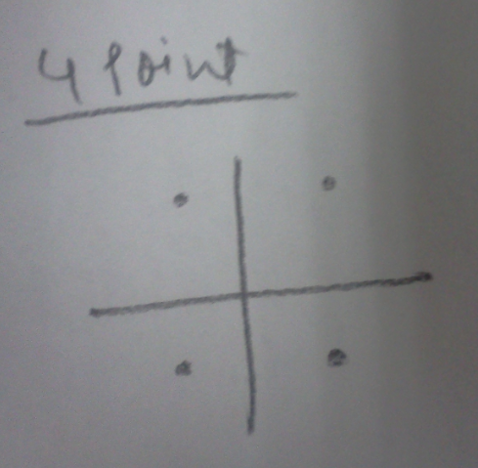

### 8 point Square Prediction

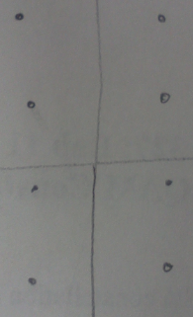

### 16 point Square Prediction

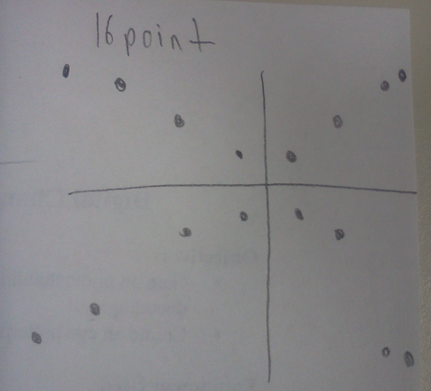

### 4 point Circle Prediction

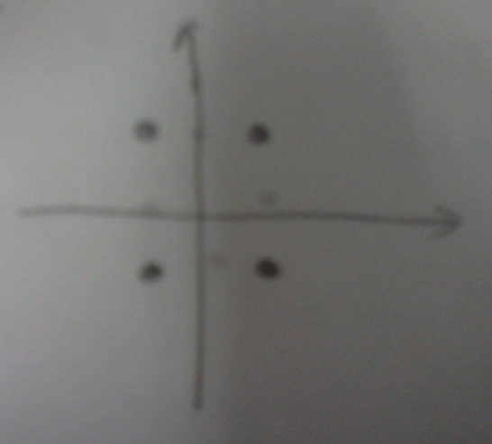

### 8 point Circle Prediction

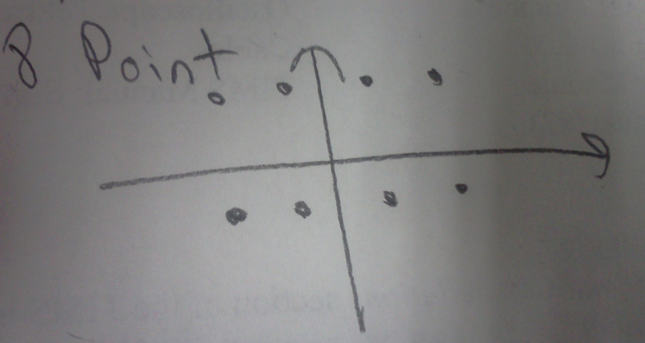

### 16 point Circle Prediction

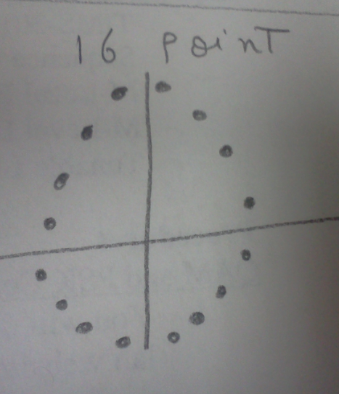

# Step 3

Complete step T5 and show the actual results (step T5) next to your predictions. (Six predictions and pictures total). Examine the constellations of each of the other signals available from the M-LEVEL ENCODER. Notice the result of using a short sequence. Record the results below.

### 4 point Square Actual:

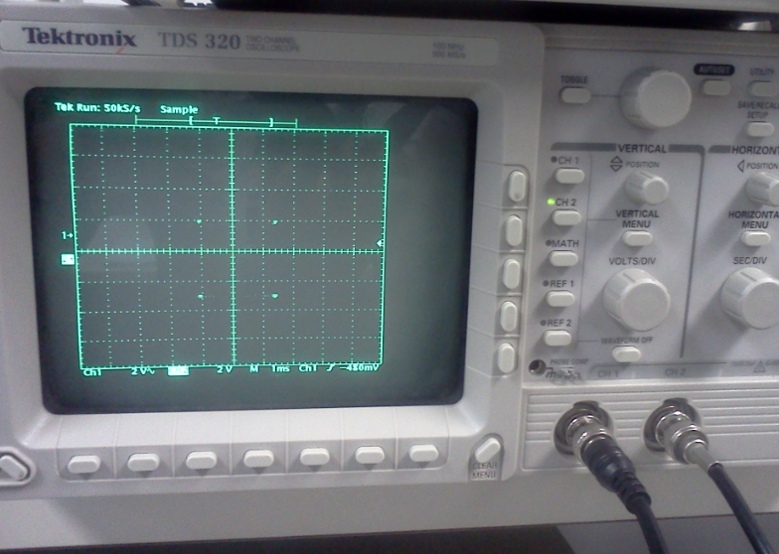

### 8 point Square Actual

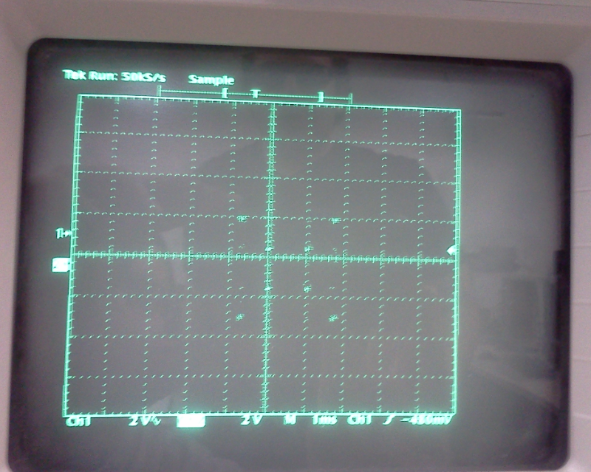

### 16 point Square Actual

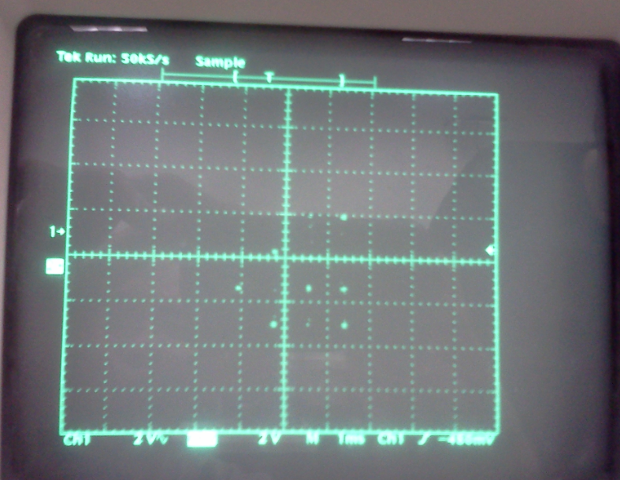

### 4 point Circle Actual

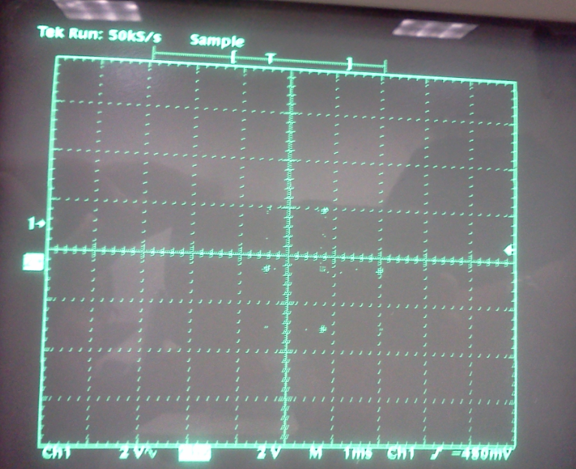

### 8 point Circle Actual

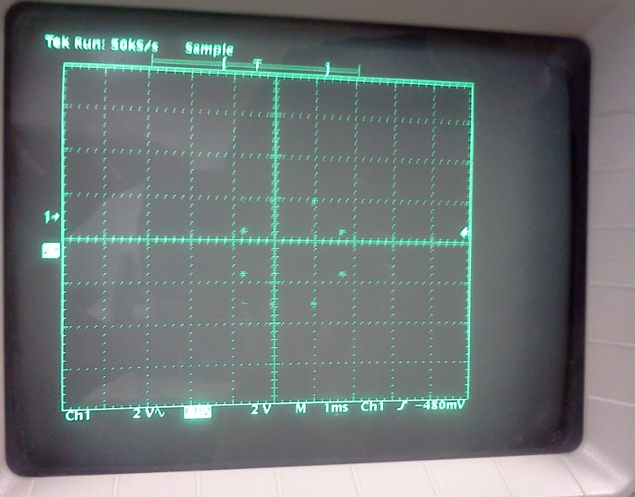

### 16 point Circle Actual

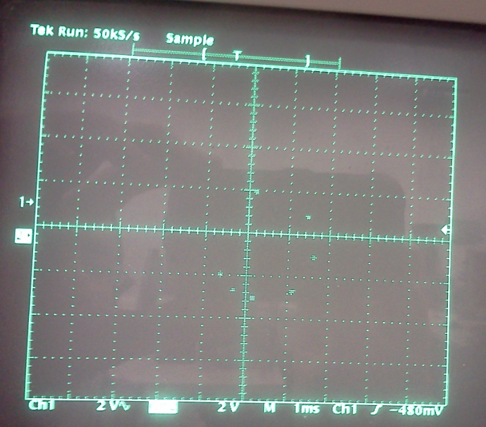

# Step 4

Go back and do step T4. Make sure to switch the oscilloscope display back to “YT” format. Compare “I” and “Q” channels against the uencoded data. Show the delay between the original and encoded signal.

Display the input serial stream and “I” output signal. Deduce the coding scheme used to map the input data to the output data. Repeat for “Q” output. Record the magnitude of the delay between the frame and the corresponding encoded output, as a function of the input data clock period. There will not necessarily be the same delay for other constellations.

The orange arrow represents data unencoded, the blue arrow represents “Q” signal, and the green arrow represents “I” signal.

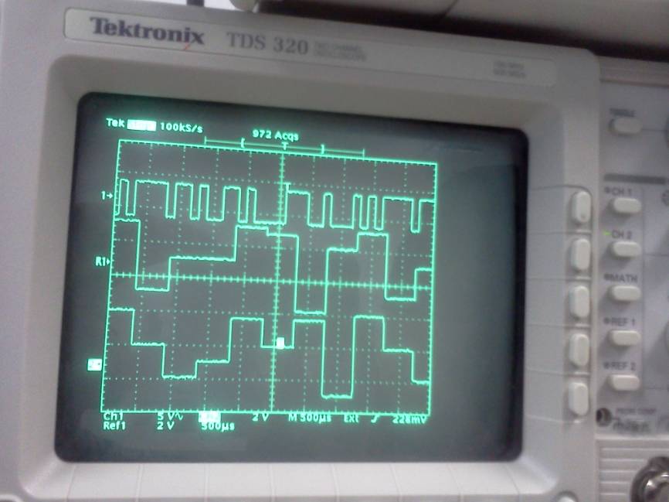

|  |  |  |
| --- | --- | --- |
| Delay between the original and encoded signal. | | |
| Encoded | Q | I |
| 1 | 1 | 1 |
| 0 | 1 | 1 |
| 1 | 1 | 1 |
| 1 | 0 | 0 |

# Step 5

Skip to step T8, switch to “XY” format and print results of the six different constellation patterns. In Figure 5, rather than having a “serial data OUT” connect “Q” and “I” to “B” on the scope selector. Switch between “A” and “B” on the scope selector and note the difference.

Connect cables up the decoding model of Figure below. Set the front panel switches to decode 4-QAM. Initially, set both the TUNEABLE LPF modules to maximum bandwidth.

### Decoder- switched for 4-QAM:

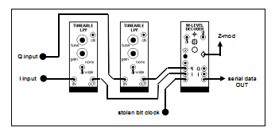

### Set up for step 5

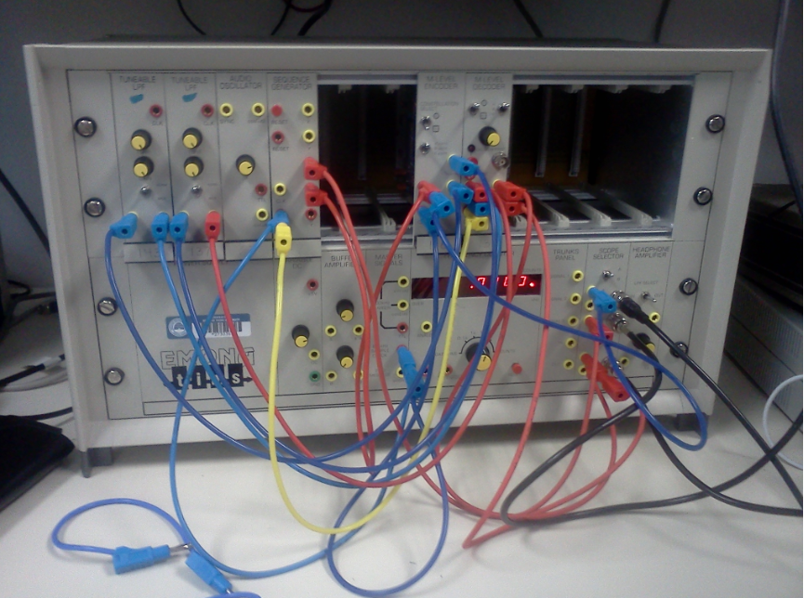

### Tims output for 4-QAM:

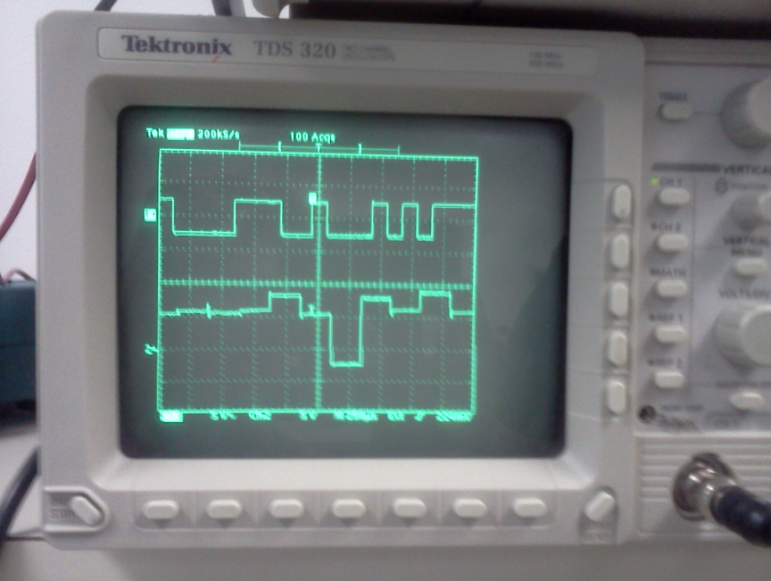

|  |  |  |  |  |  |  |  |  |  |  |
| --- | --- | --- | --- | --- | --- | --- | --- | --- | --- | --- |
| Difference between A and B looking from oscilloscope | | | | | | | | | | |
| A | 1 | 0 | 0 | 0 | 0 | 1 | 1 | 1 | 0 | 0 |
| B | 0 | 1 | 1 | 0 | 1 | 0 | 1 | 1 | 0 | 0 |

By looking at the oscilloscope I see that channel A and B are quite different, out of phase, with a few similarities in certain areas, but overall there are many differences on the signal.

# Eye Pattern

Use the below diagram on the right to see an eye diagram on an oscilloscope. For best results, turn “persist” mode on the display menu to 2 seconds. Show your results.

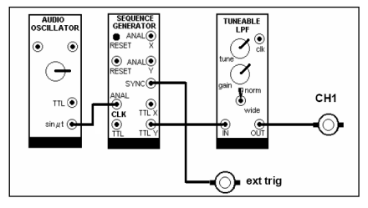

### Eye pattern set up:

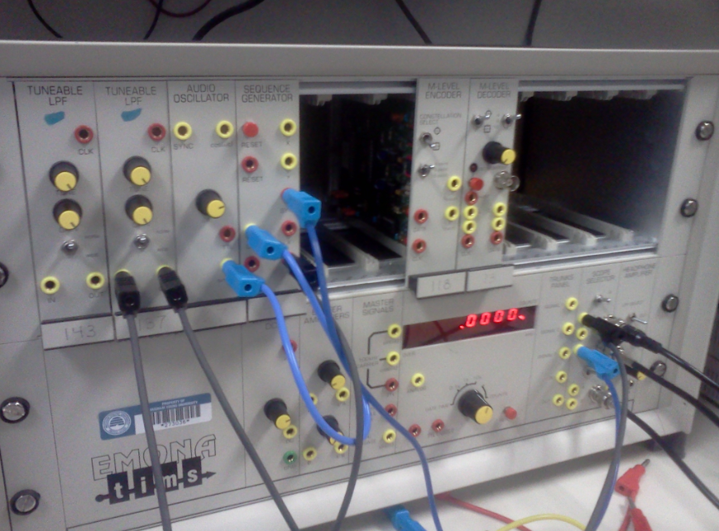

### Tims output Eye pattern:

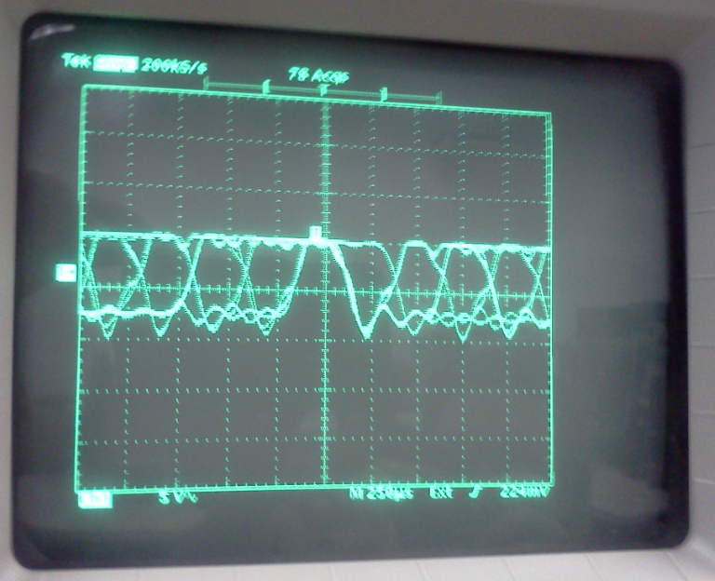

# Equipment Used

* TIMS-301 Modeling System
* Sequence Generator Module
* M-Level Encoder Module
* M-Level Decoder Module
* Tunable LPF Module (x2)
* Audio Oscillator Module
* Oscilloscope Tektronix TDS 210
* Cables
* TIMS Manual: Signal Constellations

## Questions:

Why is the 16-point QAM and PSK not what you expected?

16-point QAM and PSK are not what I expected mostly due to Noise interference, have I had the perfect signal and equipment that would block all noise, and then I would get the plots as expected.

On the 8-point QAM, why are there more than 8 points?

On the 8-point QAM, the reason there are more than 8 points is due to noise interference that reached through the machines used to measure the 8-point QAM.

Why is the eye pattern inconsistent in the middle?

An open eye pattern corresponds to minimal signal distortion. Distortion of the signal waveform due to intersymbol interference and noise appears as closure of the eye pattern.

Why is step T4 delayed?

Step T4 is delayed Because of the changing of format on the oscilloscope.

# Conclusion

This lab has reinforced me the importance of constellation plots which is a representation of a signal modulated by a digital modulation scheme such as quadrature amplitude modulation or phase-shift keying.

I have learned in this lab that constellation plots display the signal as a two-dimensional scatter diagram in the complex plane at symbol sampling instants (XY or YX). It represents the possible symbols that may be selected by a given modulation scheme as points in the complex plane. The Measured constellation diagrams can be used to recognize the type of interference and distortion in a signal, which can be very helpful if the reason you’re using the constellation plot is to discover the signal noise interference on a signal.

I have also learned that an open eye pattern corresponds to minimal signal distortion. Distortion of the signal waveform due to inter symbol interference and noise appears as closure of the eye pattern. Eye patterns are used for signal distortion detection.

**Name: Lehi Alcantara**

**Completion Date: 11/15/2011**